"Master Your DevOps AWS Course: Daily Tasks to Accelerate Progress"

17-07-2023 ( pls attach screrenshot of the solutions and submit the word document)

Task on Git:

1. Install git on Windows
2. How to check the git version
3. How to check the git present version

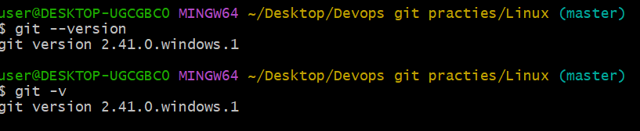

1. Downgrade your present git version to the previous version
2. How tp push code to the github Repository, pls mention the stages and commands used in it.

ANS: --

**: Git Starting Steps :**

Step 1: create one folder in loacal system and create required files.

step 2: Right click and select Git Bash

Step 3: Need to execute below commands.

#ls

Step 4: Inisilize the git.

#git init

step 5: check the status now here will find all files with red-colour.

#git status

step 6: Now we have to add the files to git.

#git add file-name

step 7: now we have to commit the file-name to Git.

#git commit -m "write your own comment"

step 8: If it first time to create new repository then need to add the Git repository URL

#git remote add origin URL here....

Step 9:check the git logs

#git logs

step 10: then we have to push the code to central repository.

#git push -u origin master

step 11: then go to Browser and refresh once it will reflect finally.....

1. How to commit a single file from staging to the local repository?

#git commit “comment” filename

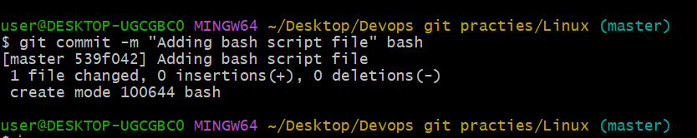

1. How do I turn a public repository into a private repository?

Ans: --go to settings🡪 Danger zone 🡪 change repository visibility 🡪 public to 🡪Private

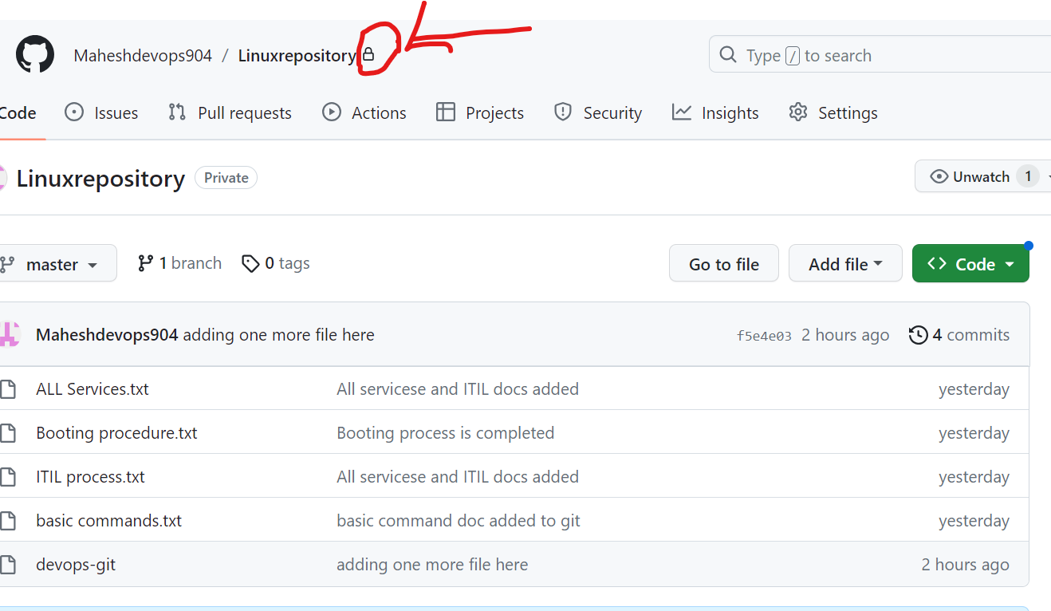

1. What is the command to check logs in git?

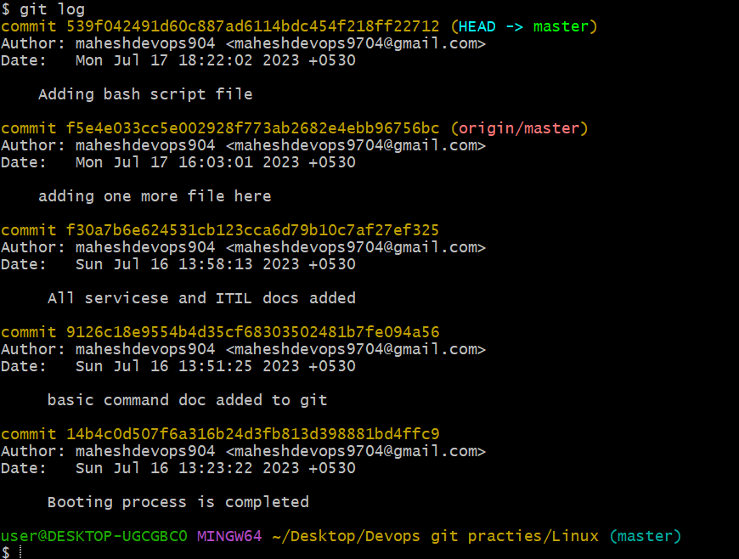

1. What is the command to check author logs in git?

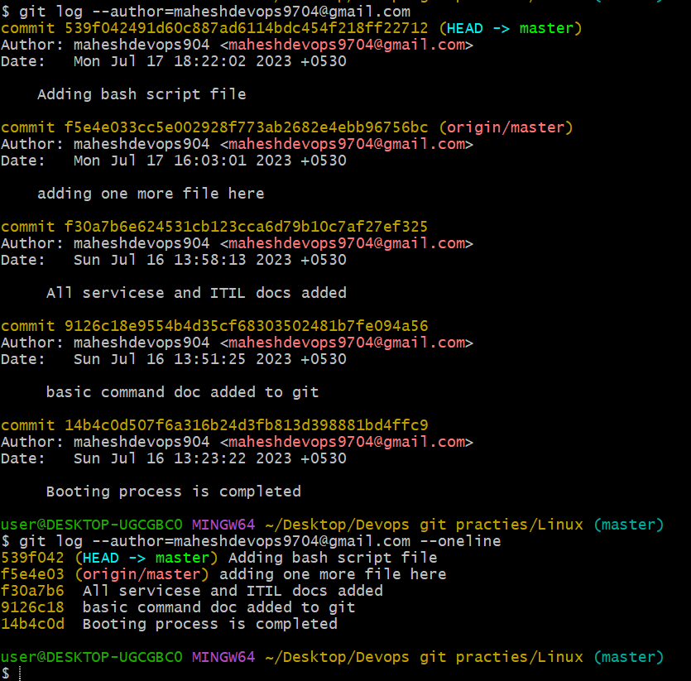

1. What is the command to logs in git based on time?

